GNG2101 Report Template

Project Deliverable C

Conceptual Design and Project Plan

Submitted by

Team A1.2

Luke DuSautoy, 300239507

Wanis Hassan, 300255946

Haonan Zhou, 300264669

Pierre Allard, 300102131

2022/10/7

University of Ottawa

#### 

Abstract

This report is to develop and document the process of creating an in-depth conceptual design. The report will also provide a project plan which will be instrumental to the next steps of the development process and aide in the creation of the team’s first prototype. By using the methods learned in class we determined the best way to create our application would be using a Python executable.

Table of Contents

Abstract i

Table of Contents ii

List of Figures iv

List of Tables v

List of Acronyms vi

1 Introduction 7

1.1 Why Conceptual Design 7

1.2 What is Conceptual Design Relevant for 7

1.3 Topic 7

2 Body of the Report 8

2.1 Functional Decomposition 8

2.2 Case Diagram 8

2.2.1 Capture User Inputs 8

2.2.2 Convert Input File to .txt 9

2.2.3 Output File for Editing 10

2.2.4 Convert from .txt to mp3 10

2.3 Analyze and Evaluate 11

2.4 Promising Solutions 12

2.5 Group Design 12

2.6 Visual Representation 13

2.6.1 State Diagram 13

3 Conclusions and Recommendations for Future Work 14

3.1 Conclusions 14

3.1.1 The benefits are as follows: 14

3.1.2 The downsides are as follows: 14

3.2 Recommendations for Future Work 14

APPENDICES 15

APPENDIX I: 15

3.3 Wrike Gantt Chart 15

List of Figures

Figure 1: State Diagram of the System 13

List of Tables

**No table of figures entries found.**

List of Acronyms

|  |  |
| --- | --- |
| **Acronym** | **Definition** |
| PDF | Portable Document Format |
| MP3 | MPEG Layer 3 (audio file) |
| ePub | Electronic publication |
| OCR | Optical Character Recognition |
| UX | User Experience |
| UI | User Interface |
| GUI | Graphic User Interface |
| DAISY | The Digital Accessible Information System |

# Introduction

## Why Conceptual Design

The conceptual design process is important framework for developing the ground level ideas of the project. It allows the designers to visualize their ideas and to develop new ones. This allowance to visualize the ideas means that there is increased clarity between team members and within one’s own concepts.

## What is Conceptual Design Relevant for

Conceptual design is extremely useful in software projects where the UI is important. Being able to create the outline without needing to code lets the team generate multiple solutions and then access the benefits and drawbacks of each to assure the final interface is as accessible and comprehensive as possible.

The conceptual design process also helps us understand the relationship between the customer and the system used to create the system requirements. The client’s relationship with the system will change over time, however it is beneficial to have as deep an understanding of this relationship as possible.

## Topic

The report will develop a conceptual design for the development of this project and establish a plan for creating future prototypes.

# Body of the Report

## Functional Decomposition

The team has decomposed the project into the four processes the program will ideally run through. First the system must interact with user to receive their required inputs, and the file that the user would like to convert. If possible, we would like to allow the users to have full control over the output of the MP3 file to best suit their needs, this would include inputs such as preferred voice and speed. Next the system must read from the input file and convert any text into a .txt document as this will make the next step more efficient and will work on any device. This process would ideally be able to extract text using OCR on .jpeg and .png files in the case that users have image files which they require to extract the text from. The interface will then display the generated .txt file and allow the user to make the desired corrections in case there are issues with the previous process. Once the system has the corrected file it will then convert this into a .mp3 or. daisy which will be placed directly into the file which the user has specified completing the client’s request.

## Case Diagram

### Capture User Inputs

Website, CSS, and html, dropdown to select which input types and a button to submit, this would meet the specification for a website and allows other specifications to be met. The drop-down menus would allow the user to select the appropriate voice and speed, however, may be less accessible to some users.

Similar to naturalreaders follow along by highlighting text, this is very accessible and easy to use. This accessibility would come at the cost of some features.

Like apple, long scrolling page – static background clear and easy to follow, scrolling may reduce accessibility of users on smaller devices. Room for many of the target specification features.

### Convert Input File to .txt

(PHP)[spatie/pdf-to-text: Extract text from a pdf (github.com)](https://github.com/spatie/pdf-to-text) Uses unfamiliar language and speed is less than required in the target specifications, however within marginal specifications.

(Python) [Convert PDF to TXT file using Python - AskPython](https://www.askpython.com/python/examples/convert-pdf-to-txt#:~:text=Steps%20to%20Convert%20PDF%20to%20TXT%20in%20Python,IDLE%20and%20press%20keys%20ctrl%20%2B%20N.%20) Familiar language would allow the code to be adjusted to attempt to meet the desired target specification.

(JavaScript) [How to convert PDF to Text (extract text from PDF) with JavaScript | Our Code World](https://ourcodeworld.com/articles/read/405/how-to-convert-pdf-to-text-extract-text-from-pdf-with-javascript#:~:text=How%20to%20convert%20PDF%20to%20Text%20%28extract%20text,4%204.%20Extracting%20text%20from%20multiple%20pages%20)­ Unfamiliar language however is built into web code will reduce complexity of hooks and allow for fastest form of program.

Convert pdf to text with Python: <https://www.pdftron.com/ppc/python-pdf-library/?utm_source=google&utm_medium=cpc&utm_campaign=PDFTron_Google_Search_NB_SDK_Language_Framework&utm_content=python-library&utm_term=python%20pdf%20library&gclid=CjwKCAjw7eSZBhB8EiwA60kCWwxtIGXMiYYeW-dd2Q9dv8oLALtFZZfq0K0M3jgIvSPRKSgkldVCqRoCgvoQAvD_BwE> This allows us to convert any pdf document to a text file with the use of a programming language our team is comfortable with.

Open-source image to pdf converter: <https://dawnlabs.github.io/alchemy/> - This could be used if we end up using executables, it will allow us to convert images to pdf.

Convert image to pdf: <https://datatofish.com/images-to-pdf-python/> - It helps our group to convert images first before converting pdf to speech.

### Output File for Editing

(Access) Create a database to draw from and organize chapters [Microsoft Access Application Software | Create Database Apps](https://www.microsoft.com/en-ca/microsoft-365/access) - This would increase complexity, however overall organisation and presentation to end users would be simpler.

### Convert from .txt to mp3

(xVASynth) Text to speech program: [xVASynth 2 - SKVA Synth at Skyrim Special Edition Nexus - Mods and Community (nexusmods.com)](https://www.nexusmods.com/skyrimspecialedition/mods/44184) - This allows the synthesis of any voice when provided with enough sample size. Would allow for maximum choice of voice, but heightened complexity.

Convert text to speech in Python: <https://pypi.org/project/gTTS/> - This allows us to convert the text that we had previously converted from pdf to mp3 with the same language we used for the last step, so maintaining both codes will be consistent.

(Language Translator): <https://techvidvan.com/tutorials/python-language-translator/> - It can make our project available in multiple languages.

Convert text to speech: <https://www.codingem.com/python-text-to-speech/> - This web can easily help us to build our mind about how to convert text to speech.

## Analyze and Evaluate

In our client interview we inquired if the product could be an executable of if it would need to be web-based. This was an option which they had not previously considered, the client explained that there was no preference for either, this began the discussion about which structure was best.

The team has decided that given the members experience with python It would be in our best interest to build a fully python-based executable. This would not meet the target specification of being web-based application, however, in time we may be able to migrate the python code to an html website. Given that none of the team has any JavaScript experience and that the software is intended to primarily be used by librarian, who have work laptops that can download the executable, this is the best option given the limited work time the team has available for the project. This decision means that the most relevant ideas will be those which meet target specifications and make use of python libraries. This also means that we would need to develop a python GUI most likely built using TKinter given its simplicity and ability to meet the target specifications set for accessibility.

Choosing to use Python helped to narrow down the selection of libraries to use. We then assessed the remaining libraries using the metrics created in project deliverable B. We determined which libraries had the desired features for input files, language, variable speed, and a selection of output voices.

From these few options we accessed which would be able to handle the large amount of data we would present it with. The final decision was between online and locally downloadable libraries, our team chose to use the local as it would mean that internet connectivity would not be needed for the system to work.

## Promising Solutions

By analyzing our options, we determined a solution for each part of the functional decomposition. For the UI we will use the TKinter library to implement a simple but accessible UX. Next, for the input file to .txt part of the process we will use the AskPython library, the familiar language would allow the code to be adjusted to meet the desired target specification. Finally the process of convering from the .txt to .pdf file we will use <https://pypi.org/project/gTTS/> this allows us to convert the text that we had previously converted from pdf with the same language we used for the last step, so maintaining both codes will be consistent and allow for easier implementation for future features.

## Group Design

The current design will be fully built on python. The user will download the executable on their device and interact with a GUI built using TKinter. Once the PDF file is input into the program would transform the file into a TXT file using a python script using an external module named PyPDF2 with the tutorial for its implementation found on AskPython. Next using the GUI the user will hopefully be able to edit the TXT document and resubmit the file. This file is converted into an MP3 using the pypi.org project library and is downloaded directly into the user’s designated folder.

## Visual Representation

### State Diagram

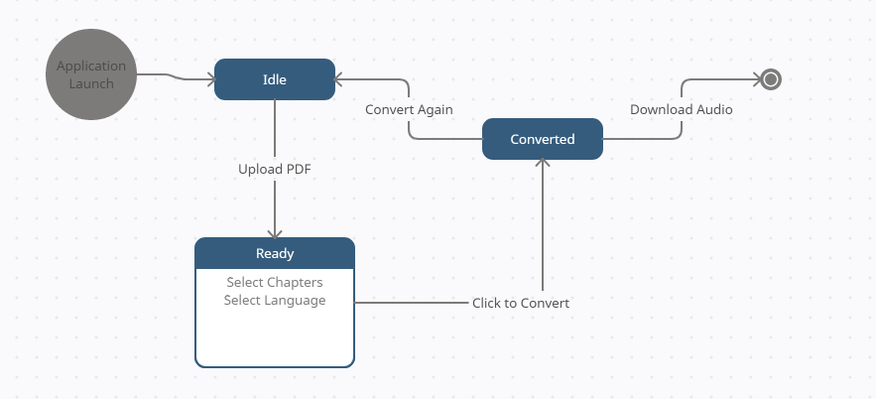

Figure 1: State Diagram of the System

# Conclusions and Recommendations for Future Work

## Conclusions

Rather than implementing a web-based solution, the application will be fully self-contained.

### The benefits are as follows:

This will allow for offline access to the application.

This will allow students to be given the program and use it independently.

This will simplify the design process and have no dependencies on external downtimes.

### The downsides are as follows:

The program will not be easily accessible on new computers (This can be worked around by uploading the program to a download site and linking it.)

The program will be limited to python libraries. This makes future upgrades and expansions

limited to existing python libraries

## Recommendations for Future Work

The next step in our development will be to build a software prototype based on the results of our conceptual design process and the input from our next client interview. The team will further define the project plan and create a bill of materials and parts required.

APPENDICES

APPENDIX I:

## Wrike Gantt Chart

<https://www.wrike.com/open.htm?id=963685331>